Assignment 11

210010033

Part1:

1. The 48 bit-ethernet address of the machine is c4:41:1e:75:b1:52 .
2. The 48 bit-ethernet address of the destination is 00:1e:c1:7e:d9:01. No, it is not the ethernet address of gaia.cs.umass.edu. It is the address of the next hop router.
3. The frame type is 0x0800. This corresponds to the IPV4 protocol.
4. ‘G’ appears after 65 bytes in the Ethernet frame.
5. Ethernet source address is 00:1e:c1:7e:d9:01. Next hop router (3ComEurope_7e:d9:01) has this as its ethernet address.
6. Destination address is c4:41:1e:75:b1:52. Yes, this is the ethernet address of the device used for capturing the trace.
7. The type is 0x0800. It corresponds to IPV4 protocol.
8. 14th byte is the position of O in OK in HTTP. 80th byte is the position of O in OK from start of ethernet frame.
9. 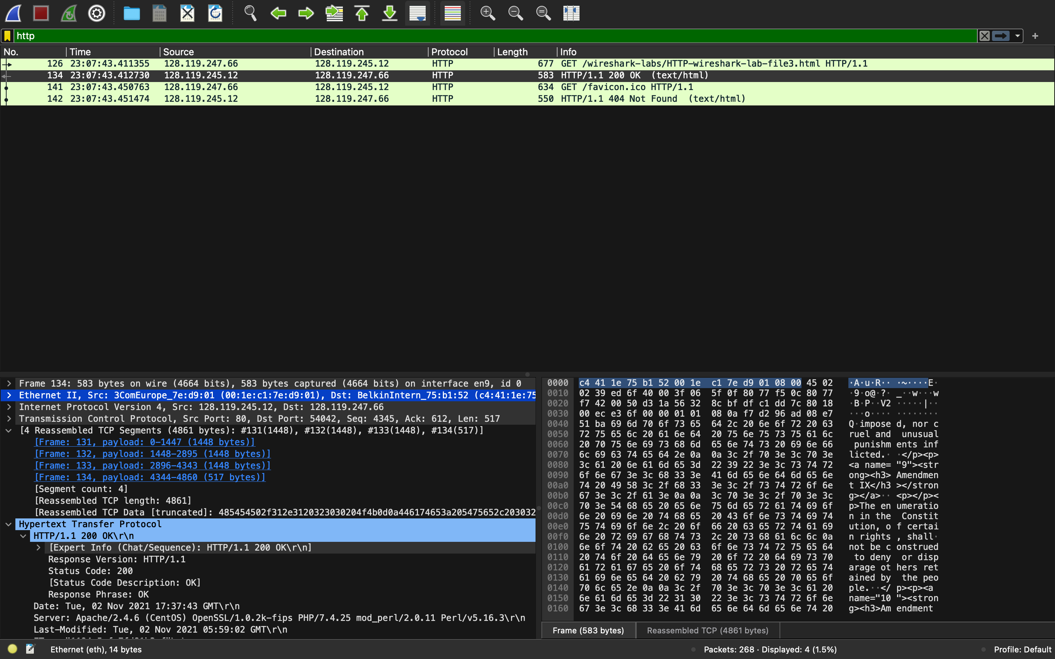4 different Ethernet frames contain carry data that is part of the complete HTTP “OK 200 ...” reply message.  
     
   Part2:

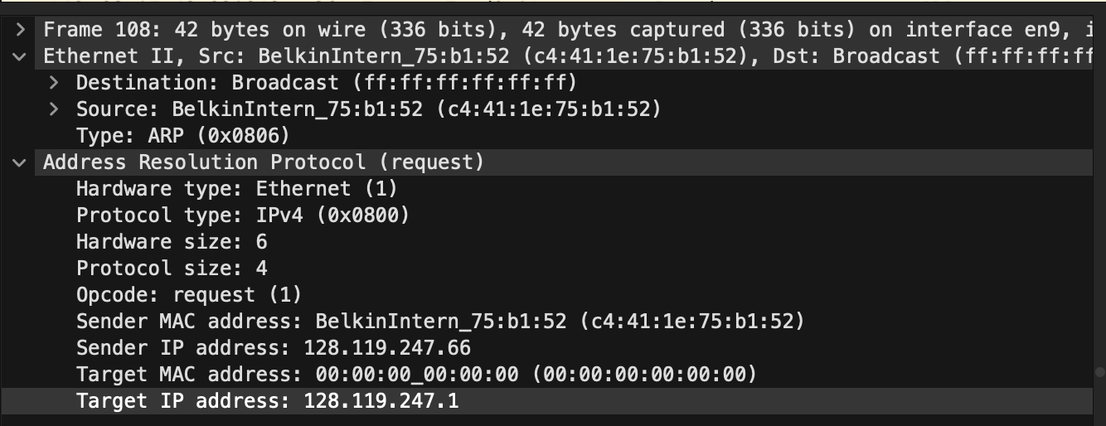

1. 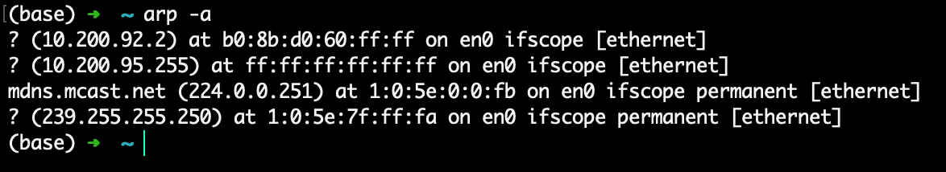  
     
   There are 4 entries in my arp cache.
2. Each entry is of the form ***(IP address)*** *at* ***MAC address*** *on* ***interface***
3. Source address is c4:41:1e:75:b1:52.
4. Destination address is ff:ff:ff:ff:ff:ff. This does not correspond to any device.
5. Type is 0x0806. The upper layer protocol here is ARP.
6. The opcode starts from the 21st byte.
7. Opcode field values is request (1)
8. Yes. Sender IP address is 128.119.247.66
9. Target IP address: 128.119.247.1
10. 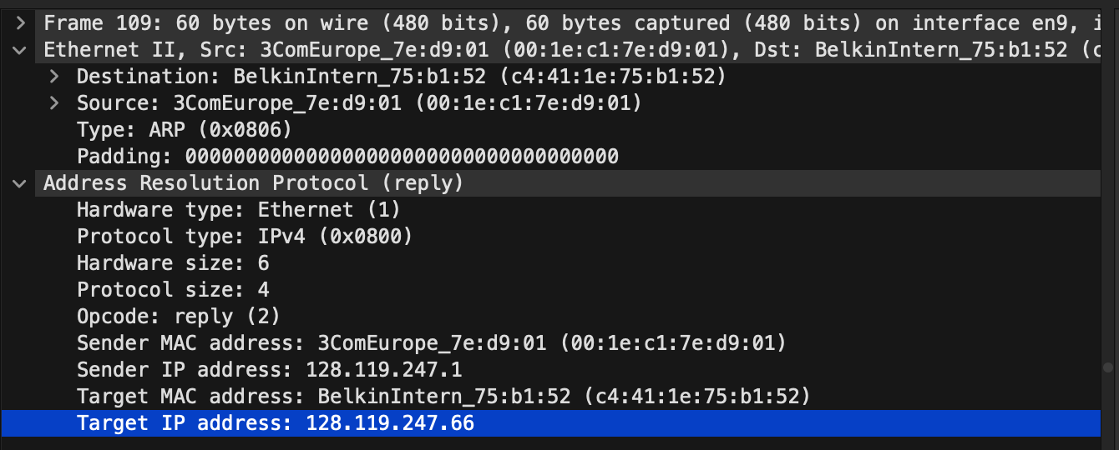Opcode field value is reply (2)
11. Target MAC address is c4:41:1e:75:b1:52 .
12. The reply comes only to the one sending the queries.